JENKINS PIPELINE TASKS
Create one Declarative pipeline job Source Code: https://github.com/betawins/spring3-mvc-maven-xml-hello-world-1.git
pipeline {
agent any

tools {
maven 'MVN_HOME'
}

environment {
NEXUS_VERSION = 'nexus3'
NEXUS_PROTOCOL = 'http'
NEXUS_URL = '54.221.117.254:8081'
NEXUS_REPOSITORY = 'RELEASE'
NEXUS_CREDENTIAL_ID = 'Nexus'

GROUP_ID = 'com.ncodeit'
ARTIFACT_ID = 'ncodeit-hello-world'
}

stages {

stage('Checkout') {
steps {
checkout scm
}
}

stage('Read & bump version') {
steps {
script {
def currentVersion = sh(
script: "mvn help:evaluate -Dexpression=project.version -q -DforceStdout",
returnStdout: true
).trim()

def parts = currentVersion.tokenize('.')
env.RELEASE_VERSION = "${parts[0]}.${(parts[1] as int) + 1}"

sh "mvn versions:set -DnewVersion=${env.RELEASE_VERSION} -DgenerateBackupPoms=false"
}
}
}

stage('Build & Test') {
steps {
sh 'java -version'
sh 'mvn -version'
sh 'mvn -B clean package'
}
}

stage('Archive WAR') {
steps {
archiveArtifacts artifacts: 'target/*.war', fingerprint: true
}
}
}

post {
success {
echo "✅ Build successful, version ${env.RELEASE_VERSION}"
}
failure {
echo "❌ Build failed"
}
}
}
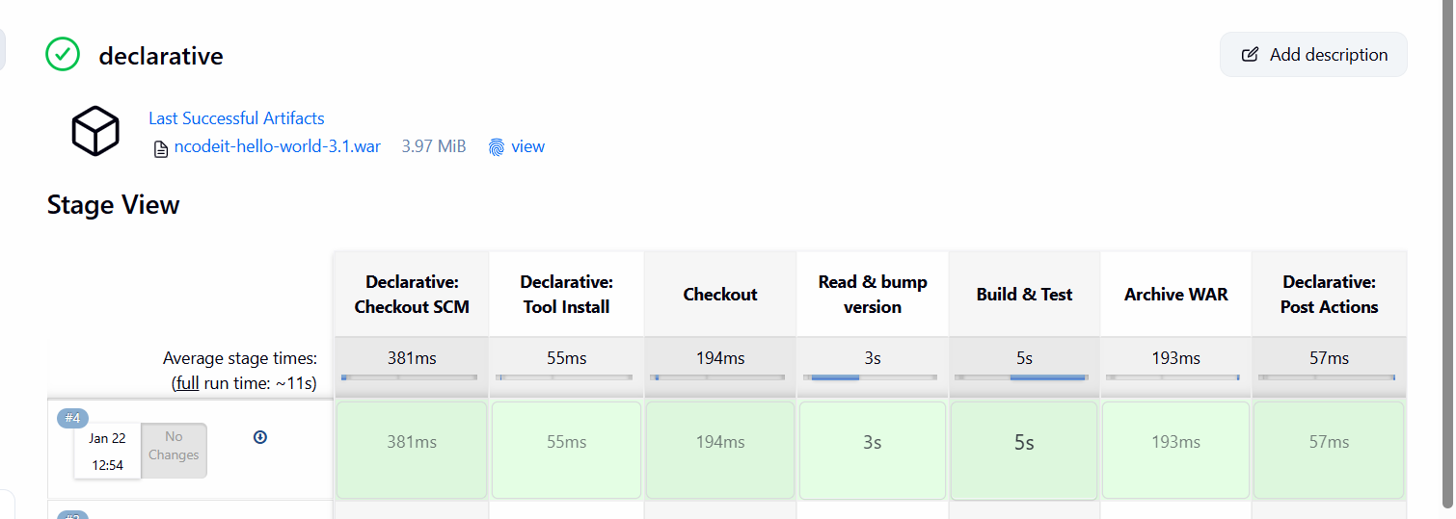
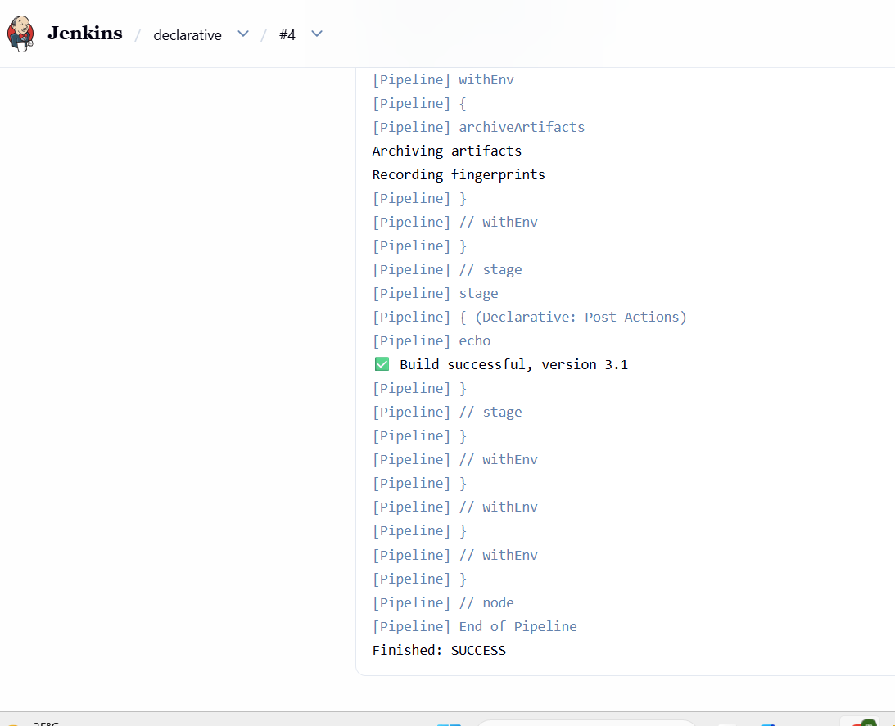

Create one Scripted pipeline jobSource Code: https://github.com/betawins/spring3-mvc-maven-xml-hello-world-1.git
node {

// Use the Maven tool already configured in Jenkins
def mvnHome = tool 'MVN_HOME'

stage('clone') {
checkout scm
}

stage('build') {
sh 'java -version'
sh "${mvnHome}/bin/mvn -version"
sh "${mvnHome}/bin/mvn clean package"
}

stage('test') {
sh "${mvnHome}/bin/mvn test"
}

stage('archive') {
archiveArtifacts artifacts: 'target/*.war', fingerprint: true
}
}

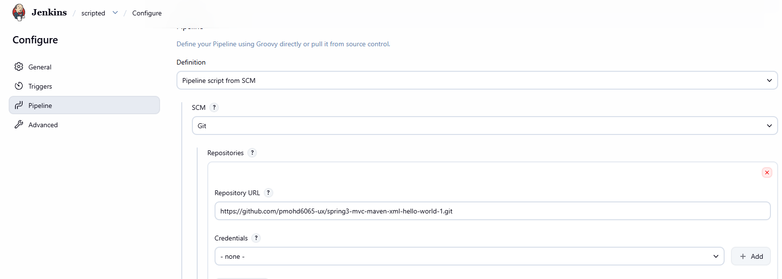
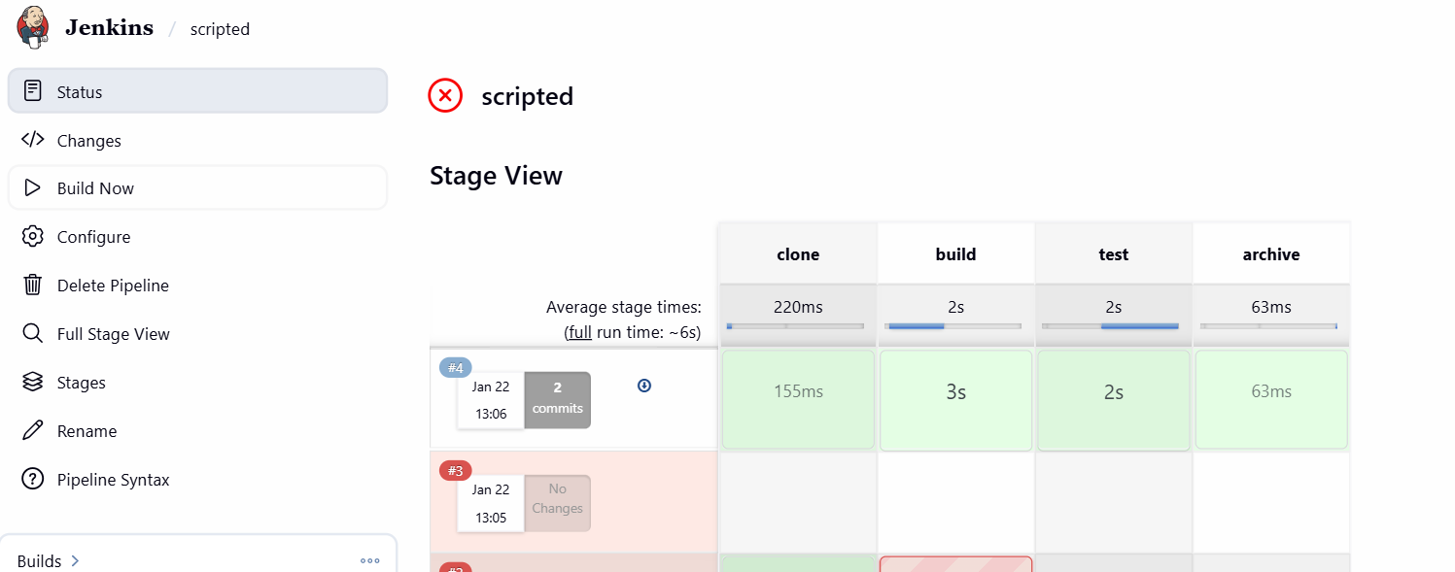
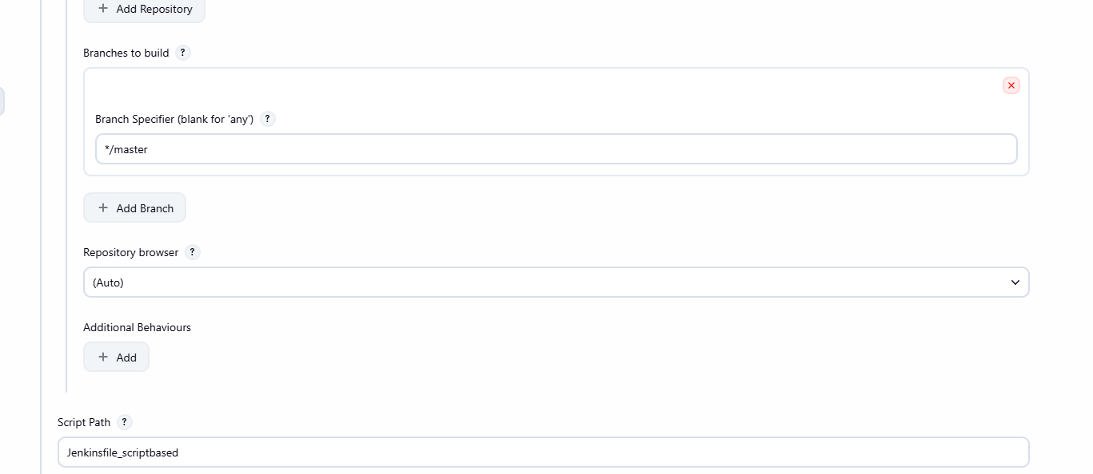
Create one Parameterized jobSource Code: https://github.com/betawins/spring3-mvc-maven-xml-hello-world-1.git
node {

/* ========= PARAMETERS ========= */
properties([
parameters([
string(
name: 'BRANCH_NAME',
defaultValue: 'master',
description: 'Git branch to build'
),
booleanParam(
name: 'SKIP_TESTS',
defaultValue: false,
description: 'Skip unit tests'
)
])
])

/* ========= TOOLS ========= */
def mvnHome = tool 'MVN_HOME'

/* ========= STAGES ========= */

stage('clone') {
checkout([
$class: 'GitSCM',
branches: [[name: "*/${params.BRANCH_NAME}"]],
userRemoteConfigs: [[
url: 'https://github.com/pmohd6065-ux/spring3-mvc-maven-xml-hello-world-1.git'
]]
])
}

stage('build') {
sh 'java -version'
sh "${mvnHome}/bin/mvn -version"

if (params.SKIP_TESTS) {
sh "${mvnHome}/bin/mvn clean package -DskipTests"
} else {
sh "${mvnHome}/bin/mvn clean package"
}
}

stage('test') {
if (!params.SKIP_TESTS) {
sh "${mvnHome}/bin/mvn test"
} else {
echo 'Tests skipped'
}
}

stage('archive') {
archiveArtifacts artifacts: 'target/*.war', fingerprint: true
}
}

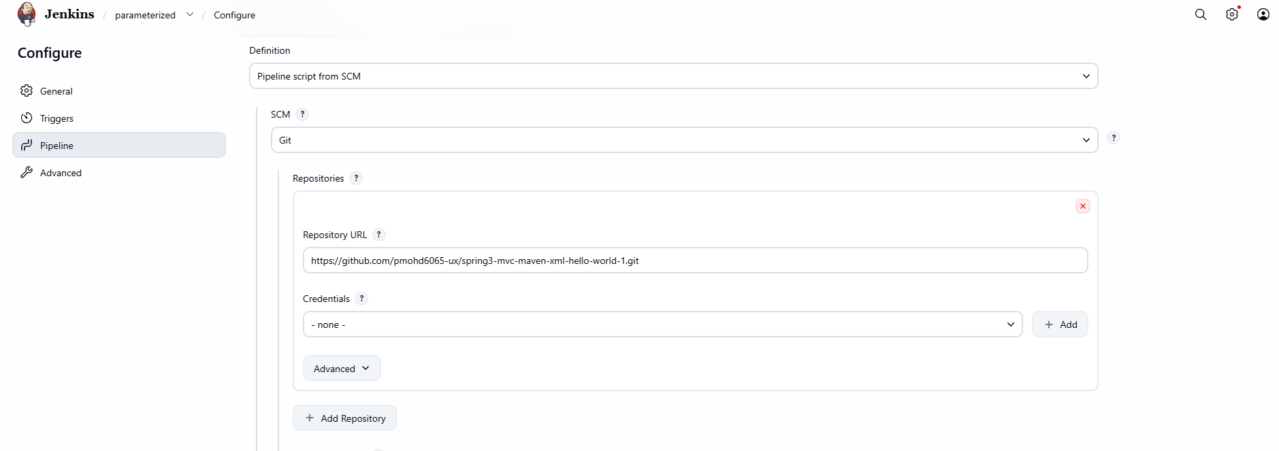
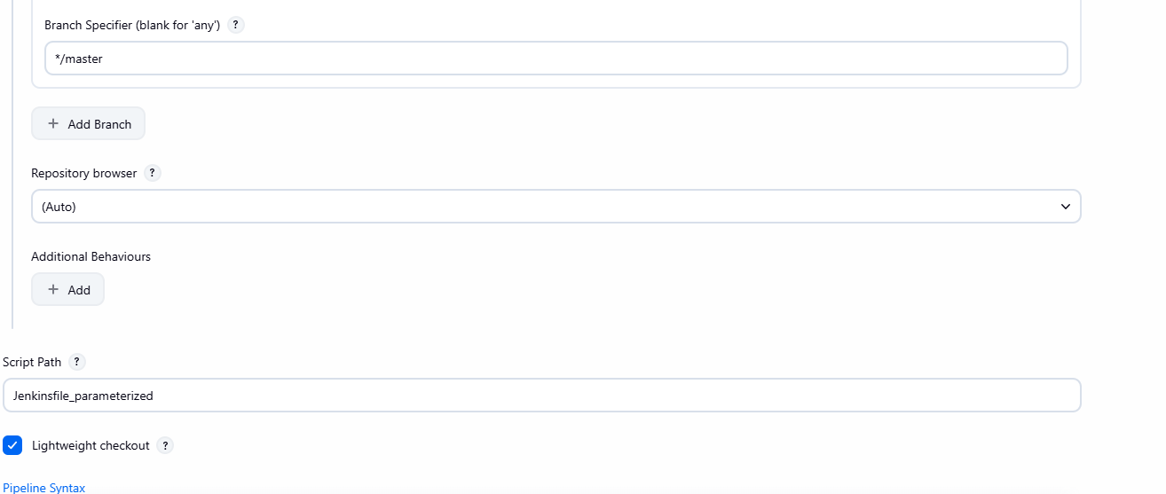
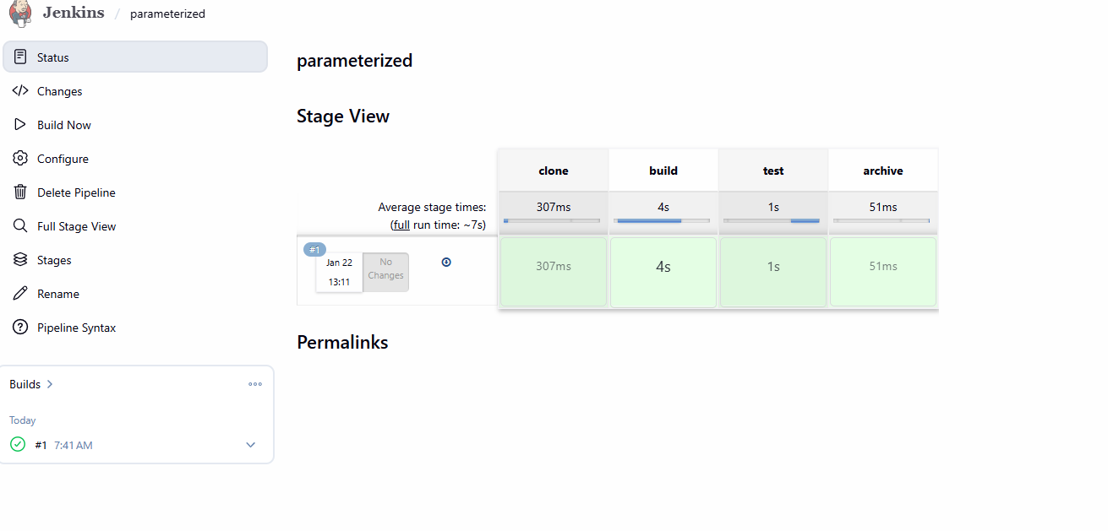
Write sample skeleton for Declarative and Scripted pipelines

Declarative Pipeline — Sample Skeleton

pipeline {
agent any

environment {
ENV_NAME = 'dev'
}

tools {
maven 'MVN_HOME'
}

stages {

stage('Checkout') {
steps {
checkout scm
}
}

stage('Build') {
steps {
sh 'mvn clean compile'
}
}

stage('Test') {
steps {
sh 'mvn test'
}
}
}

post {
success {
echo 'Build successful'
}
failure {
echo 'Build failed'
}
always {
echo 'Pipeline finished'
}
}
}
```

Scripted Pipeline — Sample Skeleton

node {

stage('Checkout') {
checkout scm
}

stage('Build') {
sh 'mvn clean compile'
}

stage('Test') {
sh 'mvn test'
}
}
7.Execute parallel stages using Jenkins pipeline for any sample job
pipeline {
agent any

tools {
maven 'MVN_HOME'
}

stages {
stage('Checkout') {
steps {
git branch: 'master',
url: 'https://github.com/lerockwins/spring3-mvc-maven-xml-hello-world-1.git'
}
}

stage('Parallel Stages') {
parallel {
stage('Build') {
steps {
echo "Building application..."
sh 'mvn clean compile'
}
}

stage('Unit Tests') {
steps {
echo "Running unit tests..."
sh 'mvn test || true'
}
}

stage('Code Scan') {
steps {
echo "Simulating static code scan..."
sh 'echo "SonarQube / Lint scan simulation"'
}
}
}
}

stage('Package') {
steps {
sh 'mvn clean package -DskipTests'
}
}

stage('Archive') {
steps {
archiveArtifacts artifacts: 'target/*.war', fingerprint: true
}
}
}

post {
success {
echo "Parallel pipeline executed successfully"
}
failure {
echo "Parallel pipeline failed"
}
}
}

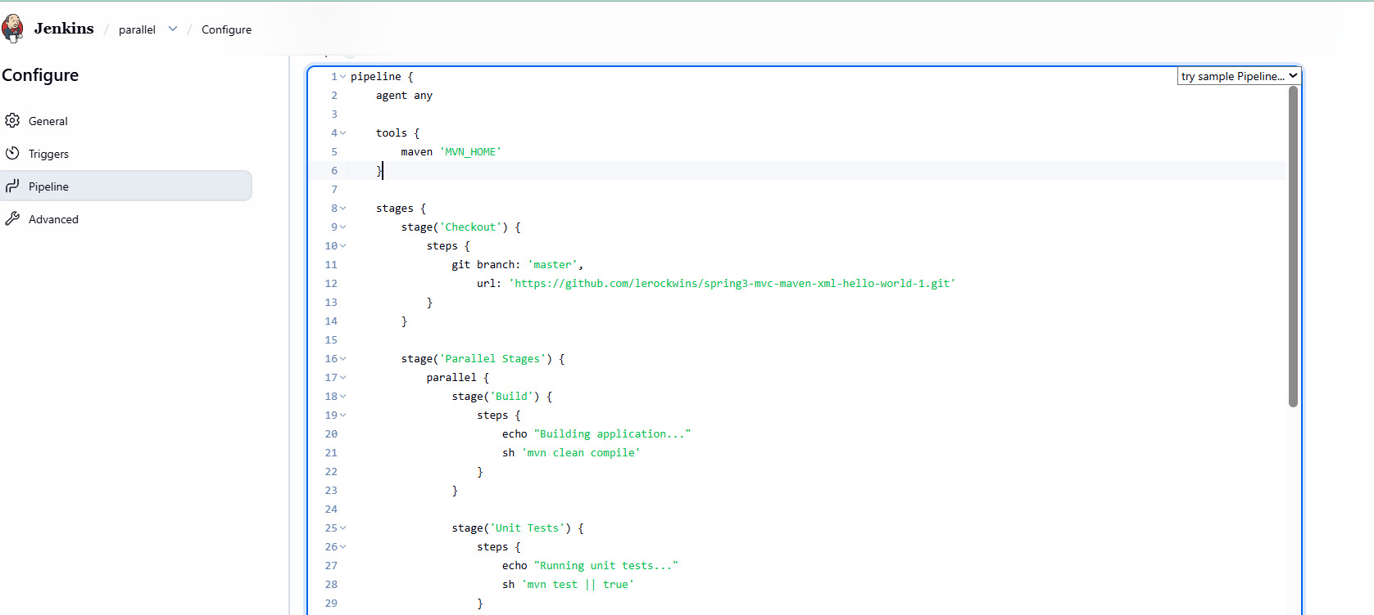
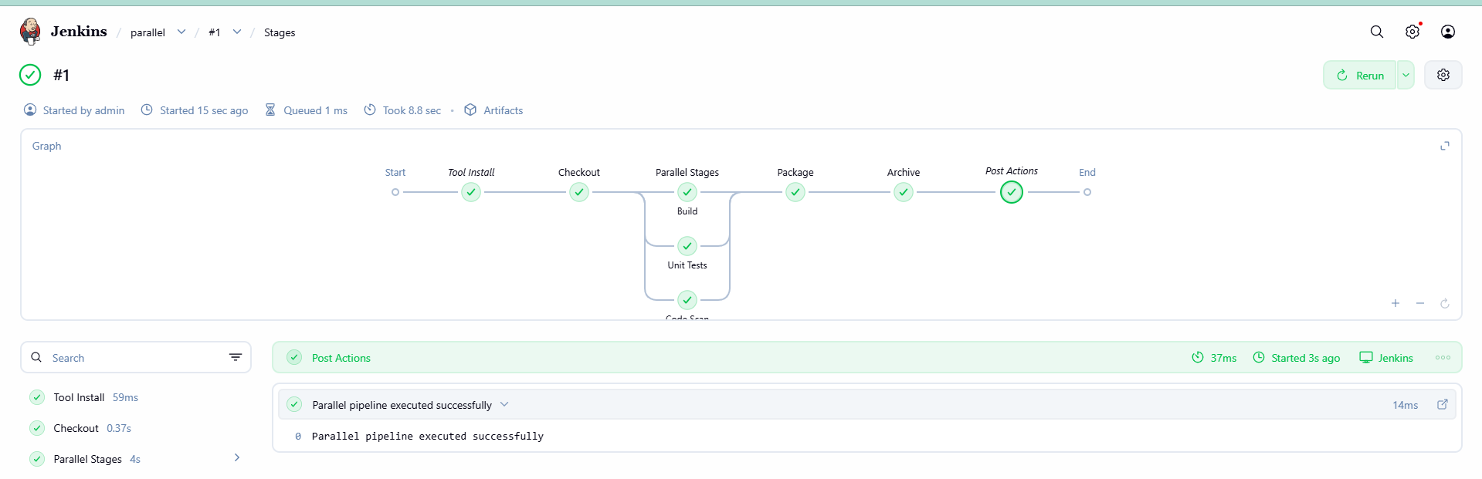
Execute Jenkins pipeline stages using shared libraries Reference: https://phoenixnap.com/kb/jenkins-shared-library Step:1

Create a new repo: with name of jenkins-shared-lib

Nd in that repo create file:jenkins-shared-lib/
└── vars/
└── commonStages.groovy
Content of vars/commonStages.groovy:
def checkoutCode(String repo, String branch) {
echo "Checking out source code..."
git branch: branch, url: repo
}

def buildApp() {
echo "Building application..."
sh 'mvn clean compile'
}

def testApp() {
echo "Running tests..."
sh 'mvn test || true'
}

def packageApp() {
echo "Packaging application..."
sh 'mvn clean package -DskipTests'
}

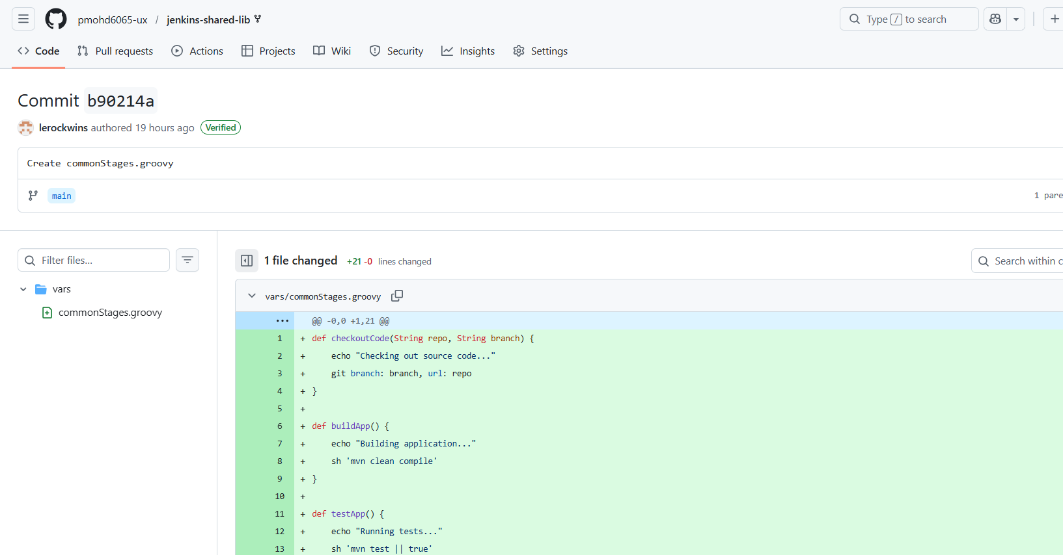
Configure Shared Library in Jenkins
In Jenkins:
Manage Jenkins → Configure System
Scroll to Global Pipeline Libraries
Add Library:
Name: common-lib
Default version: main (or master)
Retrieval method: Modern SCM
Git URL:
https://github.com/lerockwins/jenkins-shared-lib.git
Save.
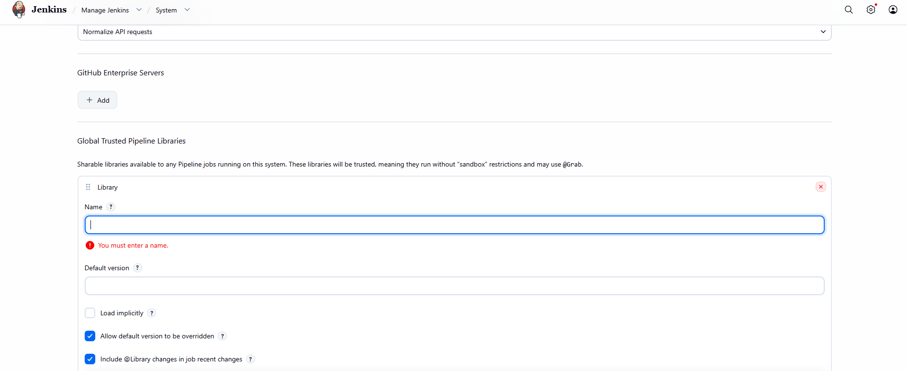
Create Jenkins Job
New Item → Pipeline
Name: spring-sharedlib-job
Definition: Pipeline script from SCM
Repo:
https://github.com/lerockwins/spring3-mvc-maven-xml-hello-world-1.git
Branch: */master
Script Path:
Jenkinsfile_shared
Save → Build Now
This job now:
Uses Shared Library
Calls reusable methods:
checkoutCode
buildApp
testApp
packageApp
This completes:
Execute Jenkins pipeline stages using shared libraries

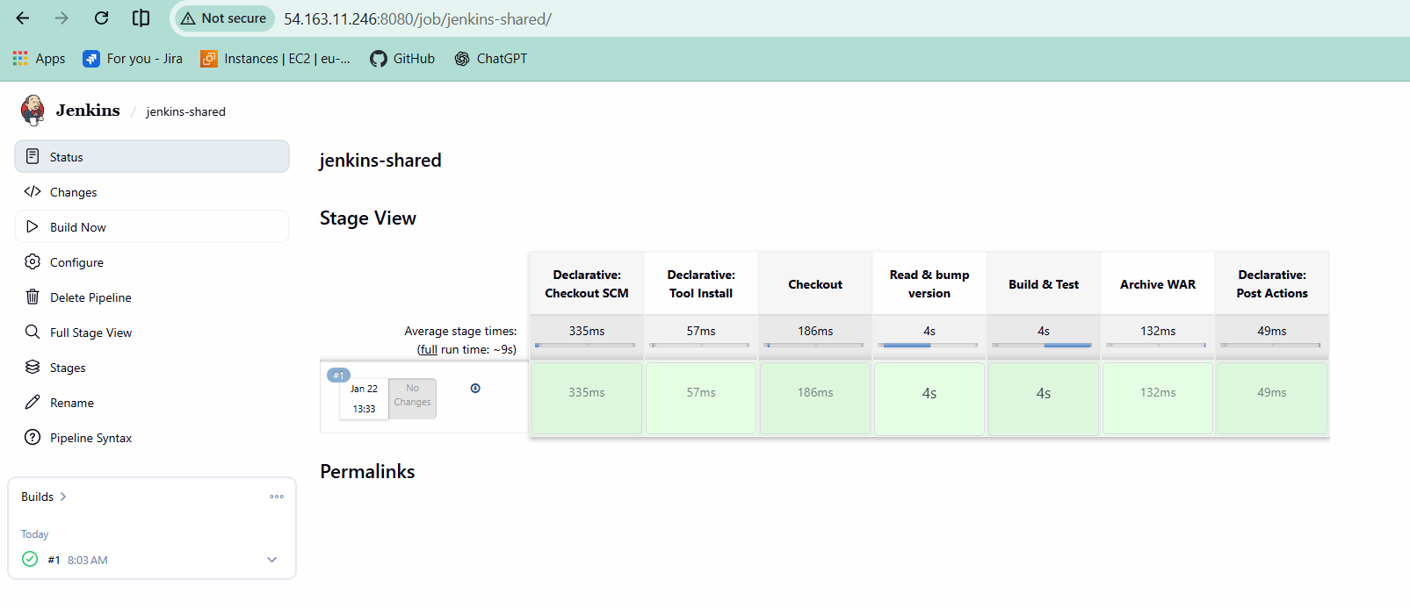
Knowledge Base by phoenixNAP
Jenkins Shared Library: How to Create, Configure and Use Jenkins Shared Libraries help automate software development by letting developers reuse scripts for multiple projects.

